**1.Download dataset from the link: https://community.tableau.com/s/question/0D54T00000CWeX8SAL/samplesuperstore-sales-excelxls Create dashboard of Sales.**

Follows this steps:

**Step 1: Download the Dataset**

* Go to the link: Sample Superstore Excel File
* Click Download to save the .xls file to your computer.

### Step 2: Open Tableau and Connect to Data

1. On the start screen, click **Microsoft Excel**.
2. Browse and select the downloaded Sample - Superstore.xls file.
3. Drag the **Orders** sheet into the canvas.

### Step 3: Create Visualizations

### 1.Sales by regions

* Drag Region to Columns
* Drag Sales to Rows
* Choose **Bar Chart**

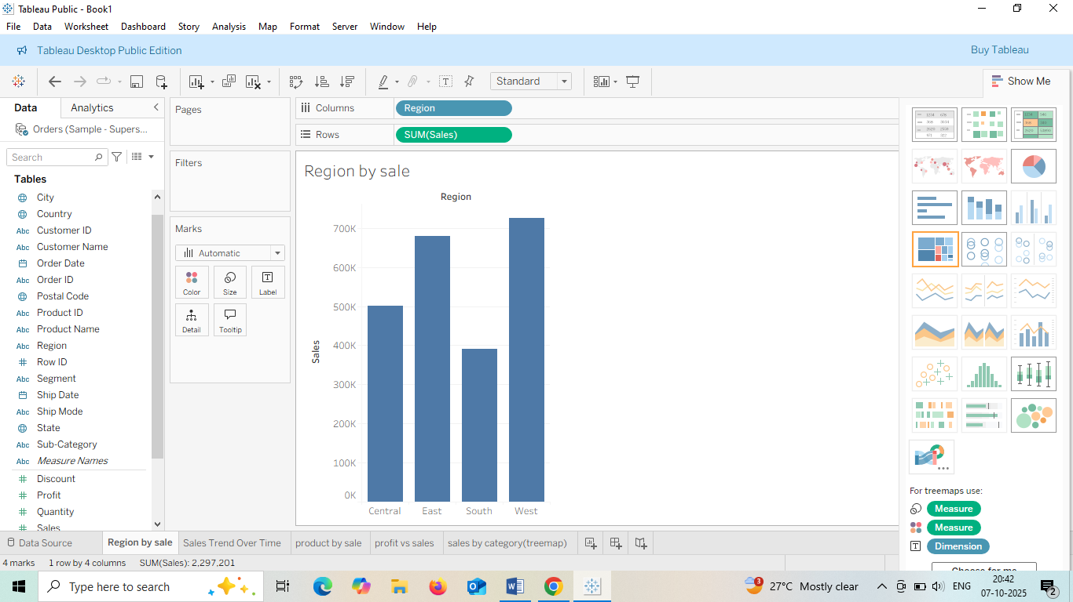

**2.Sales Trend Over Time**

* Drag Order Date to Columns (set to Month or Year)
* Drag Sales to Rows
* Choose **Line Chart**

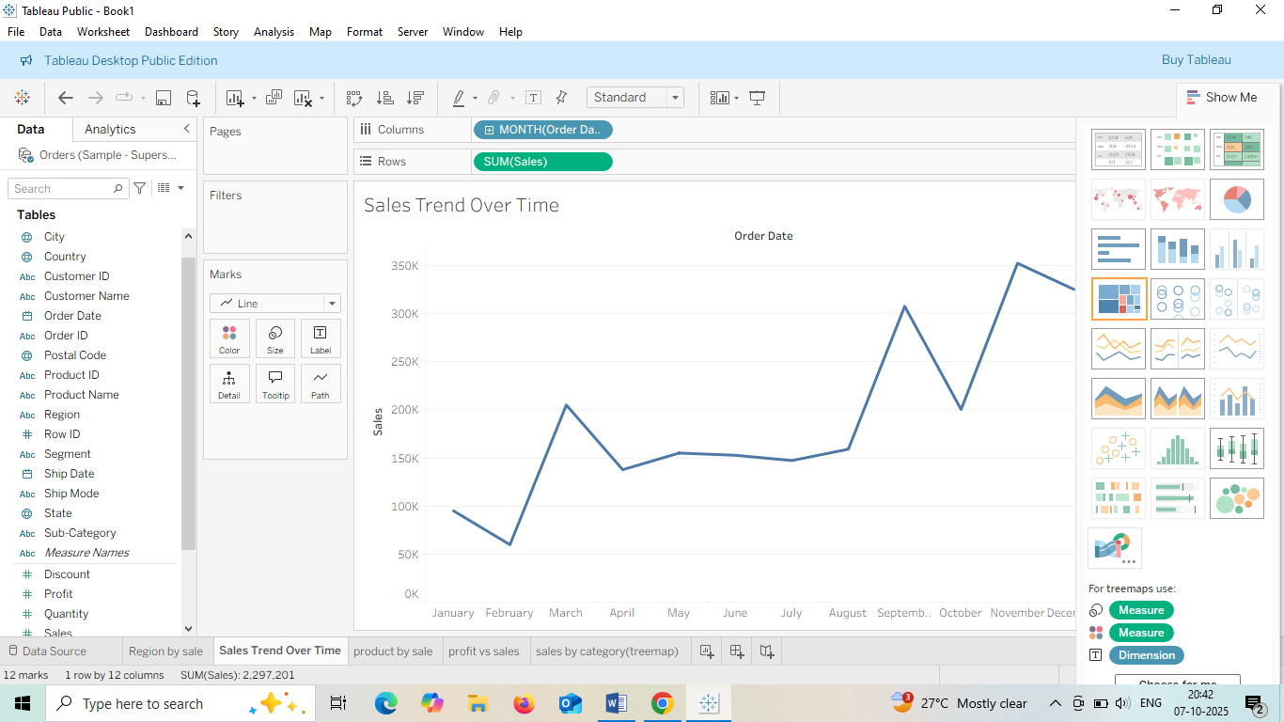

#### **3.** Top 10 Products by Sales

* Drag Product Name to Rows
* Drag Sales to Columns
* Sort descending
* Apply filter to show **Top 10**

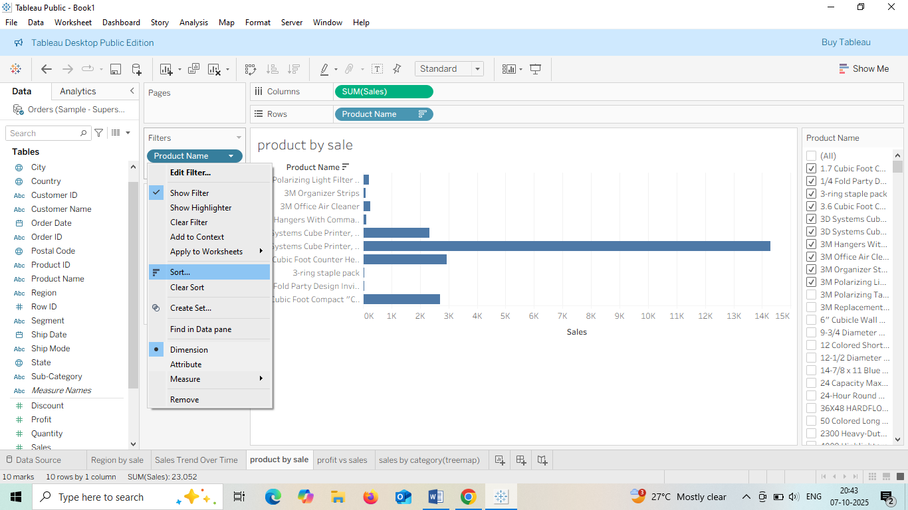

#### **4.** Profit vs Sales Scatter Plot

* Drag Sales to Columns
* Drag Profit to Rows
* Add Category to Color

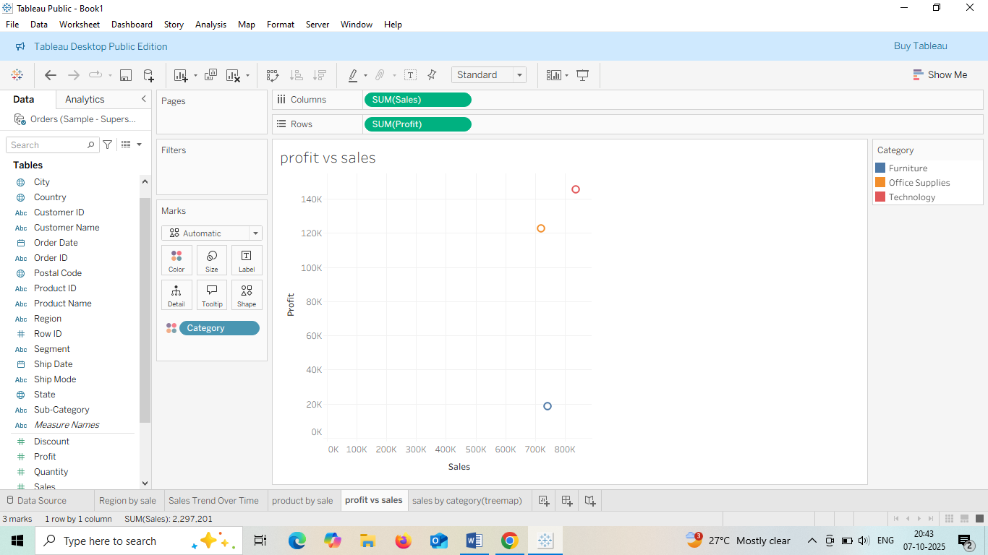

#### **5.** Sales by Category and Sub-Category

* Use a **Treemap** or **Stacked Bar Chart**
* Drag Category and Sub-Category to Rows
* Drag Sales to Size or Columns

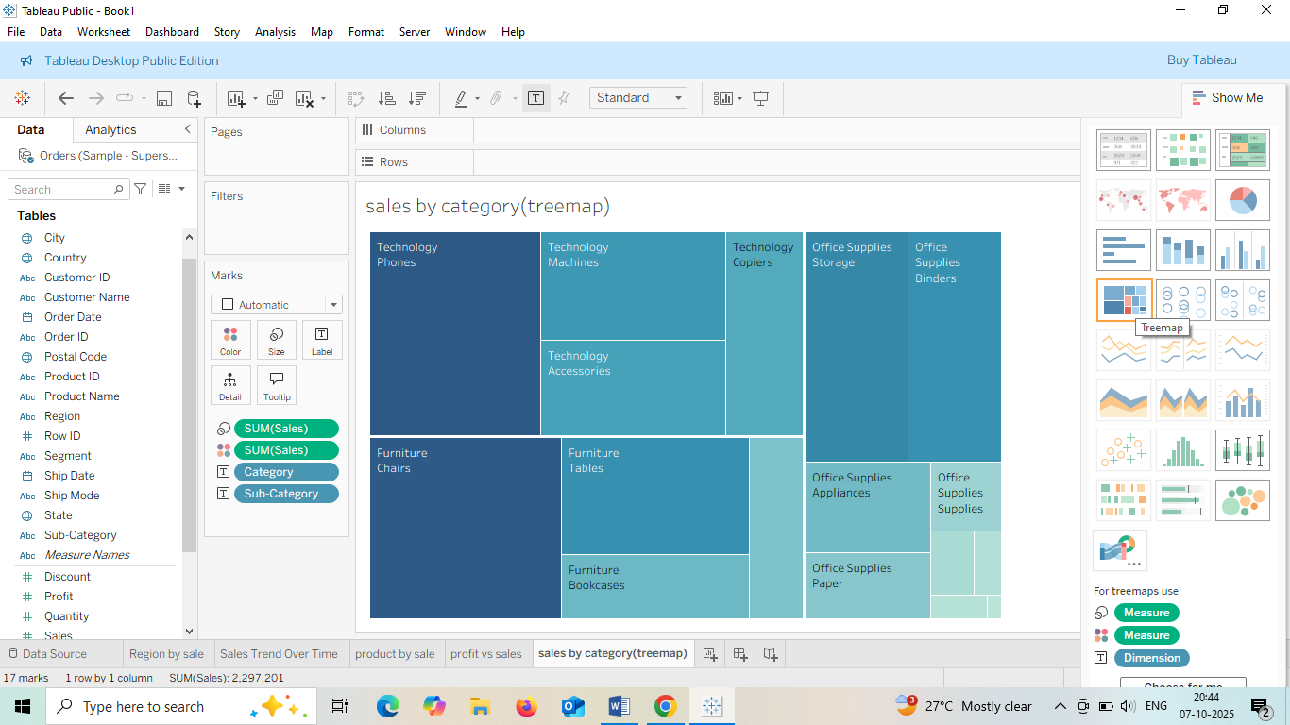

### Step 5: Build the Dashboard

1. Click the **Dashboard** tab at the bottom.
2. Drag each worksheet into the dashboard canvas.
3. Add **Filters**
4. Use **Text boxes** for titles.
5. Adjust layout for clarity and aesthetics.

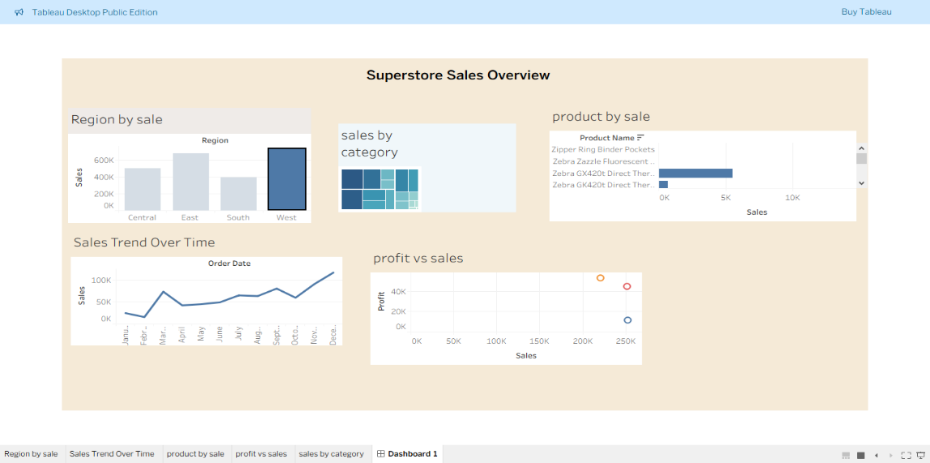

* 1. **Create different charts for Sales like pie chart, bar graph etc. Do data visualization and save project.**

### 1. **Open Tableau**

* Launch Tableau Desktop or Tableau Public.

### 2. **Connect to Data**

* Click **Microsoft Excel**.
* Select the downloaded file Sample - Superstore.xls.
* Drag the **Orders** sheet into the canvas.

### 3. **Create Charts for Sales**

#### Bar Chart – Sales by Region

* Drag Region to Columns.
* Drag Sales to Rows.
* Choose **Bar Chart** from Show Me.

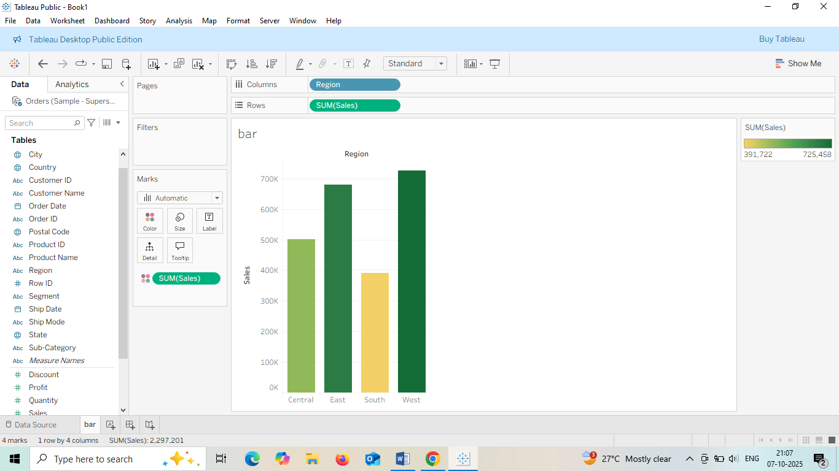

#### Pie Chart – Sales by Category

* Drag Category to Rows.
* Drag Sales to Size.
* Choose **Pie Chart** from Show Me.
* Add Category to Color and Label.

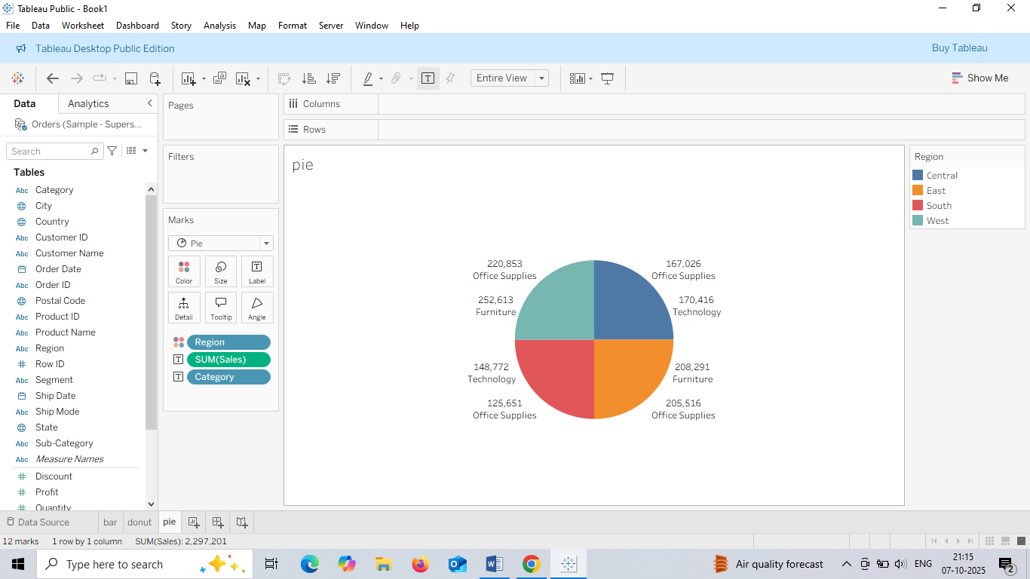

#### Line Chart – Sales Over Time

* Drag Order Date to Columns (set to Month/Year).
* Drag Sales to Rows.
* Choose **Line Chart**.

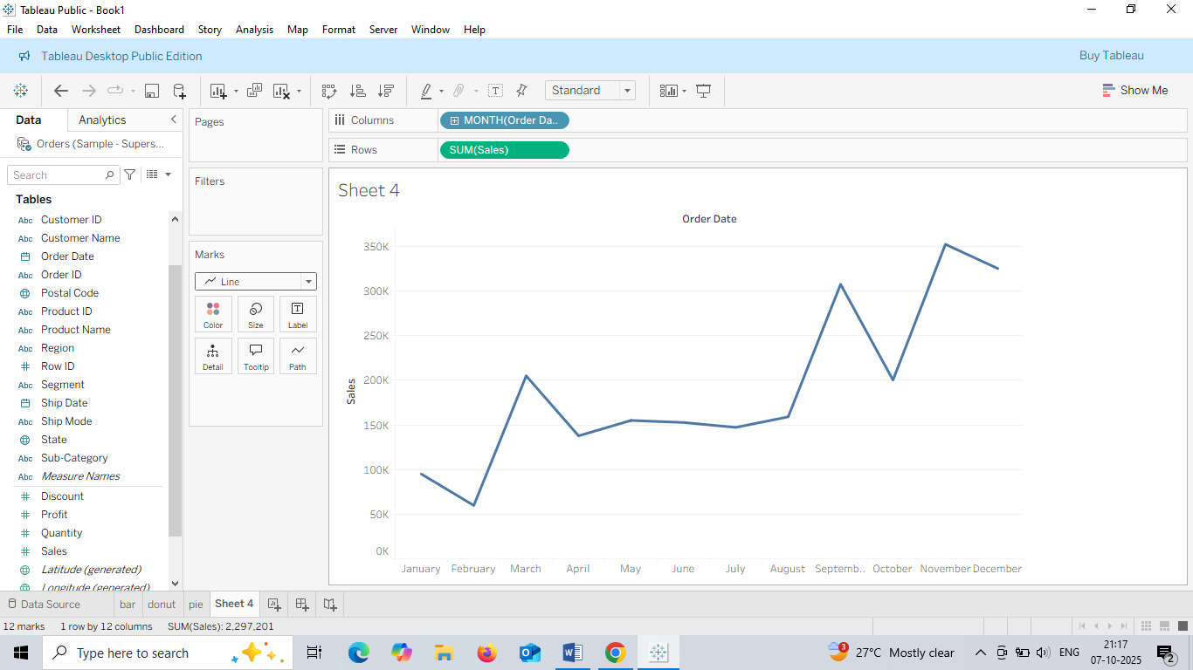

#### Treemap – Sales by Sub-Category

* Drag Sub-Category to Rows.
* Drag Sales to Size.
* Choose **Treemap** from Show Me.

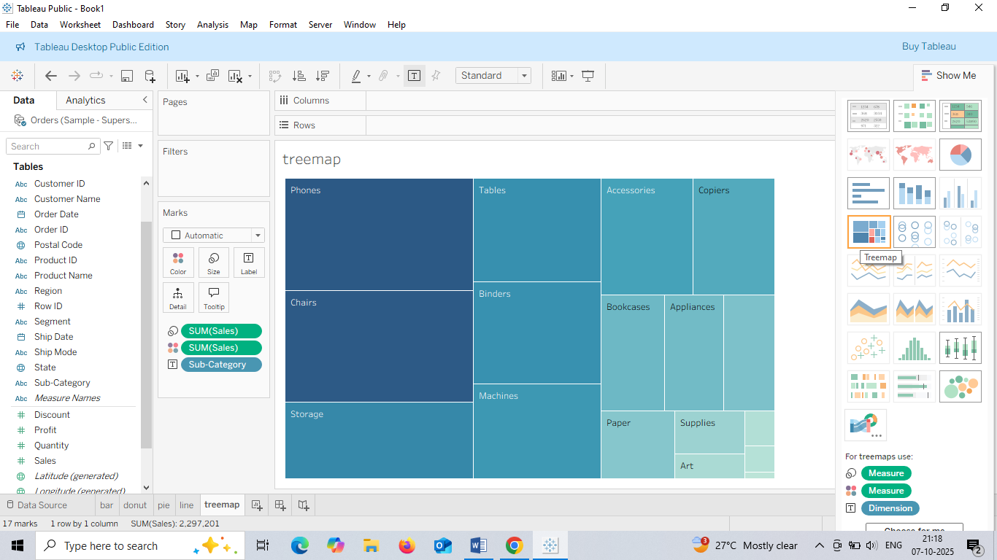

#### Scatter Plot – Profit vs Sales

* Drag Sales to Columns.
* Drag Profit to Rows.
* Add Category to Color.

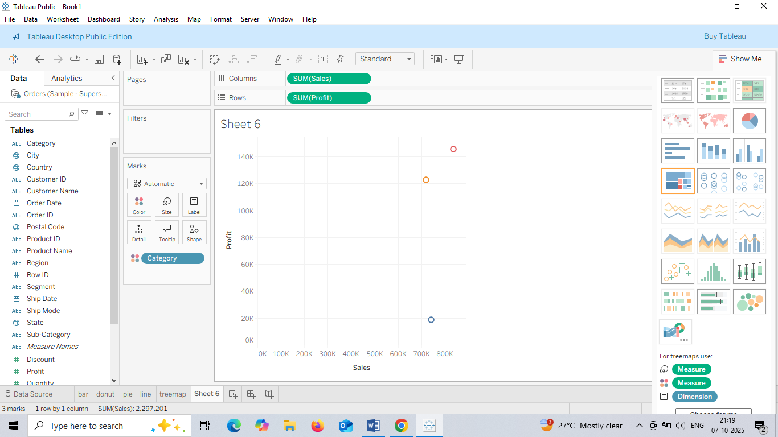

### **Save Project**

* Click **File > Save As**.
* Choose .twb or .twbx format.
* Name your project Sales visualization.

**1. Download dataset from the link: https://community.tableau.com/s/question/0D54T00000CWeX8SAL/samplesuperstore-sales-excelxls Use aggregates, calculated fields, handle text/ date fields.**

### Step 1:

* Go to this link: Sample Superstore Excel File

### Step 2:

1. Open **Tableau Desktop**.
2. Click **Microsoft Excel** under “Connect”.
3. Select the downloaded file: Sample - Superstore.xls.
4. Drag the **Orders** sheet to the canvas.

### Step 3:

* Go to **Sheet 1**.
* Drag **Sales** to **Rows**.
* Drag **Region** to **Columns**.
* change aggregation by:
  + Right-clicking the field → **Measure** → choose **SUM**, **AVG**, **COUNT**, etc.

### Step 4:

1. Click the dropdown arrow in the **Data Pane** → **Create Calculated Field**.

[Profit] / [Sales]

* Name it Profit Ratio and click **OK**.

### Step 5: Handle Text Fields

* Drag **Category** or **Sub-Category** to Rows or Filters.
* Use **Filters** to include/exclude specific text values.
* Use calculated fields to clean or format text

UPPER([Category])

### Step 6: Handle Date Fields

* Drag **Order Date** to Columns.
* Tableau auto-groups by Year/Quarter/Month.
* Right-click → choose **Exact Date** or **Custom Date Format**.
* Create calculated date fields:

YEAR([Order Date])

### Save Your Workbook

* Go to **File** → **Save As** → choose .twb or .twbx.

1. **Apply logical functions/ parameters, search text fields.**

### Step 1: Apply Logical Functions

like IF, THEN, ELSE.

1. Go to **Analysis** → **Create Calculated Field**.
2. Name it High Profit Flag.
3. Enter this formula:

IF [Profit] > 100 THEN "High" ELSE "Low" END

• Click **OK**.

• Drag High Profit Flag to **Color** or **Rows** to visualize.

### Step 2: Create Parameters

1. Go to **Data Pane** → Right-click → **Create Parameter**.
2. Name it Sales Threshold.
3. Set:
   * Data type: **Float**
   * Current value: **500**
4. • Click **OK** and then **Show Parameter Control**.
5. • Create a calculated field:

IF [Sales] > [Sales Threshold] THEN "Above" ELSE "Below" END

1. Use this field to filter or color your chart.

### Step 3: Search Text Fields

You can search or filter text fields like Category, Customer Name, etc.

1. Drag Customer Name to **Filters**.
2. Choose **Wildcard Match**.
3. Type part of the name (e.g., *Smith*) to find matches.

#### Search with Calculated Field

1. Create a calculated field:

CONTAINS([Customer Name], "Smith")

1. Use it as a filter or highlight condition.
2. **Download dataset from the link: https://community.tableau.com/s/question/0D54T00000CWeX8SAL/samplesuperstore-sales-excelxls Apply Calculations and Level of Detail Calculations, perform different calculations.**

**Step1:**

* Open Tableau → Connect to **Excel** → Select Sample - Superstore.xls → Drag **Orders** sheet to canvas.

### Step 2: Apply Basic Calculations

1. Go to **Analysis** → **Create Calculated Field**.
2. Name it Profit Ratio.

Formula

[Profit] / [Sales]

Click OK.

### Step 3: Detail (LOD) Calculations

#### FIXED LOD Example: Total Sales per Customer

1. Create a calculated field:

{ FIXED [Customer Name] : SUM([Sales]) }

#### INCLUDE LOD Example: Average Sales per Product

1. Create a calculated field:

{ INCLUDE [Product Name] : AVG([Sales]) }

#### EXCLUDE LOD Example: Sales excluding Region

1. Create a calculated field:

{ EXCLUDE [Region] : SUM([Sales]) }

### Use Calculated Fields in Visuals

* Drag your calculated fields into **Rows**, **Columns**, **Color**, or **Label**.
* Use **Filters** to test how LOD expressions behave under different conditions.

### Save Workbook

* Go to **File** → **Save As** → choose .twb or .twbx.

Apply quick/customized table calculations, implement level of detail expressions.

**Step1:**

• Open Tableau and connect to Sample - Superstore.xls.

• Drag Order Date to **Columns** and Sales to **Rows**.

• Right-click on Sales in the view → **Quick Table Calculation** → choose:

* **Running Total**
* **Percent of Total**
* **Year over Year Growth**
* **Rank**

### Customize It:

* Right-click the field → **Edit Table Calculation**.
* Choose **Compute Using** (e.g., Table (Across), Specific Dimensions).
* Add filters or sort to see changes dynamically.

Step-by-Step: Customized Table Calculations

### Difference from Previous Month

1. Create a calculated field:

LOOKUP(SUM([Sales]), -1)

Name it Previous Month Sales.

Create another field:

SUM([Sales]) - [Previous Month Sales]

## Step-by-Step: Level of Detail (LOD) Expressions

### 🔹 FIXED LOD: Total Sales per Customer

{ FIXED [Customer Name] : SUM([Sales]) }

### 🔹 INCLUDE LOD: Average Sales per Product

{ INCLUDE [Product Name] : AVG([Sales]) }

### 🔹 EXCLUDE LOD: Sales excluding Region

{ EXCLUDE [Region] : SUM([Sales]) }

## Visualize the Results

* Drag your calculated fields into **Rows**, **Columns**, or **Color**.
* Use **Filters** and **Parameters** to test how LODs and table calculations respond.

Download dataset from the link:

https://community.tableau.com/s/question/0D54T00000CWeX8SAL/sample-

superstore-sales-excelxls

Create symbol/ filled/ density maps, add layers/ pie charts, use viz in tooltip.

* 1. Open Tableau → Connect to **Excel** → Select Sample - Superstore.xls → Drag **Orders** sheet to canvas.

## Step 2: Create Maps

### 🔹 Symbol Map

1. Drag State to **Marks**.
2. Drag Sales to **Size** and **Color**.
3. Tableau will automatically generate a **symbol map** with circles sized by sales.

### 🔹 Filled Map

1. Drag State to **Rows**.
2. Change the **Marks type** to **Map**.
3. Drag Profit to **Color** → this fills each state with color based on profit.

### 🔹 Density Map

1. Drag City to **Marks**.
2. Change **Marks type** to **Density**.
3. Drag Sales to **Color** → this shows hotspots where sales are concentrated.

## Step 4: Add Layers and Pie Charts

### 🔸 Add Layers

1. Use **Dual Axis**:
   * Drag Latitude and Longitude to Rows and Columns.
   * Add a second field (e.g., Profit) to the same axis.
   * Right-click → **Dual Axis** → synchronize axes.
2. Customize each layer using **Marks card**.

### 🔸 Add Pie Charts on Map

1. Drag State to **Detail**.
2. Change **Marks type** to **Pie**.
3. Drag Category to **Color** and Sales to **Angle**.

Adjust **Size** to control pie chart size.

## Step : Use Viz in Tooltip

1. Create a **secondary worksheet** (e.g., Sales by Category).
2. Go back to your **main map**.
3. Click on a mark → open **Tooltip** editor.
4. Click **Insert** → **Sheets** → choose your secondary worksheet.

**2. Explore alternative map services, analyze spatial data.**

• Open Tableau → Click **Connect** → Choose your data source.

• select **Spatial File**.

## Step 2: Explore Alternative Map Services

Tableau uses **Mapbox** by default, but you can customize or switch map styles.

Change Map Style:

1. Go to **Map** → **Background Maps** → **Map Services**.
2. Choose from:
   * Tableau Standard
   * Streets
   * Satellite
   * Outdoors
   * Custom Mapbox styles (if you have a Mapbox token)

### Add Custom Map Layers:

1. Go to **Map** → **Map Layers**.
2. Toggle options like:
   * Country/State borders
   * Place names
   * Coastlines
   * Terrain

## Step 3: Analyze Spatial Data

### Create Maps:

1. Drag Latitude and Longitude to Rows and Columns.
2. Change **Marks type** to **Map** or **Circle**.
3. Drag Sales, Profit, or Category to **Color**, **Size**, or **Detail**.

**Q. Download dataset from the link: https://community.tableau.com/s/question/0D54T00000CWeX8SAL/samplesuperstore-sales-excelxls Identify trends/ forecasts/ clusters, utilize analytics pane.**

**Step1:**

1. Open Tableau → Connect to **Excel** → Select Sample - Superstore.xls → Drag **Orders** sheet to canvas.

## Step 3: Identify Trends

### 🔹 Create a Line Chart

1. Drag Order Date to **Columns**.
2. Drag Sales to **Rows`.
3. Tableau creates a line chart showing sales over time.

### 🔹 Add a Trend Line

1. Open the **Analytics pane** (on the left side of the screen).
2. Drag **Trend Line** into the view.
3. Choose **Linear**, **Logarithmic**, or **Exponential**.

## Step 4: Forecast

### 🔹 Create a Time Series

1. Use the same line chart: Order Date vs Sales.
2. Open the **Analytics pane**.
3. Drag **Forecast** into the view.
4. • Right-click the forecast → **Edit**.
5. • Choose forecast length, confidence intervals, and model type.

## Step 5: Identify Clusters

### 🔹 Create a Scatter Plot

1. Drag Sales to **Columns** and Profit to **Rows**.
2. Drag Category or Region to **Color**.

### Add Clusters

1. Open the **Analytics pane**.
2. Drag **Cluster** into the view.

Save the practical.

**Q. Incorporate lines/ forecasts, perform cluster analysis.**

## Step 1: Download and Connect to Data

* Download the Excel file from: Sample Superstore
* Open Tableau → Connect to **Microsoft Excel** → Select Sample - Superstore.xls
* Drag the **Orders** sheet to the canvas

## 📈 Step 2: Add Trend Lines

### 🔹 Create a Line Chart

1. Drag Order Date to **Columns**
2. Drag Sales to **Rows**
3. Tableau creates a time series line chart

### 🔹 Add Trend Line

1. Open the **Analytics pane** (left sidebar)
2. Drag **Trend Line** into the view
3. Choose **Linear**, **Logarithmic**, or **Exponential**
4. Tableau displays the trend line with R² value

## Step 3: Add Forecast

### 🔹 Enable Forecast

1. Use the same line chart (Order Date vs Sales)
2. Open the **Analytics pane**
3. Drag **Forecast** into the view
4. Tableau adds future projections based on historical data

## Step 4: Perform Cluster Analysis

### 🔹 Create a Scatter Plot

1. Drag Sales to **Columns**
2. Drag Profit to **Rows**
3. Drag Category or Region to **Color` (optional)

### 🔹 Add Clusters

1. Open the **Analytics pane**
2. Drag **Cluster** into the view
3. Tableau automatically groups similar data points

### 🛠 Customize Clusters

* Click the cluster legend → **Edit Clusters**
* Choose fields to base clustering on (e.g., Discount, Segment, Quantity)

Save

Q. Download dataset from the link: https://community.tableau.com/s/question/0D54T00000CWeX8SAL/samplesuperstore-sales-excelxls Create dashboard, create/ place charts, add titles

1. Open **Tableau Desktop**.
2. Click **Microsoft Excel** → select Sample - Superstore.xls.
3. Drag the **Orders** sheet to the canvas.

## Step 3: Create Charts

### 🔹 Chart 1: Sales by Region

1. Go to **Sheet 1**.
2. Drag Region to **Columns**.
3. Drag Sales to **Rows**.
4. Choose **Bar Chart** from the Marks dropdown.
5. Rename the sheet: Sales by Region.

### Chart 2: Profit Over Time

1. Go to **Sheet 2**.
2. Drag Order Date to **Columns**.
3. Drag Profit to **Rows**.
4. Choose **Line Chart**.
5. Rename the sheet: Profit Over Time.

### Chart 3: Category Breakdown

1. Go to **Sheet 3**.
2. Drag Category to **Rows**.
3. Drag Sales to **Columns`.
4. Choose **Pie Chart** from the Marks dropdown.
5. Drag Category to **Color** and Sales to **Angle**.
6. Rename the sheet: Sales by Category.

## Step 4: Create a Dashboard

1. Click the **Dashboard** tab → choose **New Dashboard**.
2. From the left pane, drag your sheets (Sales by Region, Profit Over Time, Sales by Category) onto the dashboard canvas.
3. Resize and arrange charts as needed.

## Step 5: Add Titles and Text

1. Drag **Text** from the Objects pane to the top of the dashboard.
2. Type a title like: **“Superstore Performance Dashboard”**
3. Format the text: bold, font size, alignment.
4. Add additional text boxes for descriptions or notes if needed.

## Final Step: Save and Share

* Go to **File** → **Save As** → choose .twb or .twbx.
* You can publish to Tableau Public or Tableau Server for sharing.

**Q. Show the top 5 products by total sales in the Sales Superstore dataset?**

Step1

Open **Tableau Desktop** → Click **Microsoft Excel** → Select the file → Drag the **Orders** sheet to the canvas.

## Step 2: Create a Worksheet for Top Products

1. **Open a new worksheet**.
2. Drag Product Name to **Rows**.
3. Drag Sales to Columns`.

## Step 3: Sort and Filter Top 5 Products

### 🔹 Sort by Sales

* Click the **Sort icon** on the toolbar (descending).
* Or right-click Product Name → **Sort** → By Field → Sales → Descending.

### Filter Top 5

1. Right-click Product Name → **Filter**.
2. Go to the **Top** tab.
3. Choose:
   * **By Field**
   * Top **5** by **SUM(Sales)**
4. Click **OK**.

## Add Titles and Formatting

* Click the worksheet title → Rename it to **“Top 5 Products by Sales”**.
* Format bars, labels, and colors as needed:
  + Drag Sales to **Label** to show values.
  + Use **Color** to highlight top performers.

**Q. Download dataset from the link: https://community.tableau.com/s/question/0D54T00000CWeX8SAL/samplesuperstore-sales-excelxls Create a bar chart that shows the total sales for each product sub-category.**

## Step 2: Create the Bar Chart

1. Go to a **new worksheet**.
2. Drag Sub-Category to **Rows**.
3. Drag Sales to Columns`.

## Customize the Chart

* **Sort Bars**:
  + Click the **Sort icon** on the toolbar to sort by descending sales.
* **Add Labels**:
  + Drag Sales to **Label** on the Marks card.
* **Color Bars**:
  + Drag Sales to **Color** or manually choose a color scheme.
* **Format Title**:
  + Click the worksheet title → Rename it to: **“Total Sales by Product Sub-Category”**

Save

**Q. Generate a scatter plot that displays the relationship between profit and discount for each order.**

Step1:

Open **Tableau Desktop** → Click **Microsoft Excel** → Select the file → Drag the **Orders** sheet to the canvas.

## Step 2: Create a Scatter Plot

1. Open a **new worksheet**.
2. Drag Discount to **Columns**.
3. Drag Profit to **Rows**.

## Customize

* Drag Order ID to **Detail** on the Marks card → each dot represents an individual order.
* Change **Marks type** to **Circle** (if not already selected).
* Drag Category or Region to **Color** to differentiate groups.
* Drag Sales to **Size** to show order volume.
* • Click the worksheet title → Rename it to: **“Profit vs. Discount per Order”**
* • Drag Profit or Discount to **Label** if you want to show values on hover.

Go to **File** → **Save As** → choose .twb or .twbx.

**Q. Download dataset from the link: https://community.tableau.com/s/question/0D54T00000CWeX8SAL/samplesuperstore-sales-excelxls Apply a filter to display only data for the East region. What are the total sales for this region?**

Step1:

Open **Tableau Desktop** → Click **Microsoft Excel** → Select the file → Drag the **Orders** sheet to the canvas.

## Step 2: Create a Worksheet to View Sales

1. Open a **new worksheet**.
2. Drag Region to **Filters**.
3. In the filter dialog:
   * Select only **East**
   * Click **OK**
4. Drag Sales to **Rows**.
5. Tableau will show the **total sales for the East region**.

## Step 3: Display Total Sales Clearly

* Change the **Marks type** to **Text** .
* Drag Sales to **Label** on the Marks card.
* Format the number:
  + Right-click Sales → **Format** → Choose currency or number format.

Click the worksheet title → Rename it to: **“Total Sales – East Region”**

Go to **File** → **Save As** → choose .twb or .twbx.

**Q. Sort the data to find the top 5 products with the highest profit.**

Step1:

Open **Tableau Desktop** → Click **Microsoft Excel** → Select the file → Drag the **Orders** sheet to the canvas.

## Step 2: Create a Worksheet to View Product Profit

1. Open a **new worksheet**.
2. Drag Product Name to **Rows**.
3. Drag Profit to Columns`.

## tep 3: Sort and Filter Top 5 Products

### 🔹 Sort by Profit

* Click the **Sort icon** on the toolbar (descending).
* Or right-click Product Name → **Sort** → By Field → Profit → Descending.

### 🔹 Filter Top 5

1. Right-click Product Name → **Filter**.
2. Go to the **Top** tab.
3. Choose:
4. •

**By Field**

1. Top **5** by **SUM(Profit)**

• Click **OK**.

## Customize

* Drag Profit to **Label** to show values.
* Drag Category or Sub-Category to **Color** .
* Rename the worksheet to: **“Top 5 Products by Profit”**

Go to **File** → **Save As** → choose .twb or .twbx.

**Q. Create a calculated field that calculates the profit margin for each product.**

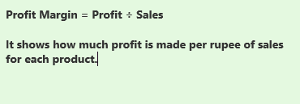

### Step 1: Open Tableau and Connect to Data

1. Open **Tableau Desktop**.
2. Connect to the Excel file: Sample - Superstore.xls.
3. Drag the **Orders** sheet to the canvas.

### Step 2: Create the Calculated Field

1. Go to any worksheet.
2. In the top menu, click **Analysis** → **Create Calculated Field**.
3. Name the field: **Profit Margin**
4. formula:

[Profit] / [Sales]

Click **OK**.

### Step 3: Use the Calculated Field

1. Drag Product Name to **Rows**.
2. Drag your new Profit Margin field to **Columns** or **Color**.
3. Format the field as a **percentage**:
   * Right-click Profit Margin → **Format** → choose **Percentage**.

**Q. Develop a calculated field that combines the product name and sub-category.**

### Step 2: Create the Calculated Field

1. Go to any worksheet.
2. Click **Analysis** → **Create Calculated Field**.
3. Name the field: **Product & Sub-Category**
4. formula:

[Product Name] + " (" + [Sub-Category] + ")"

Click **OK**.

### Use the New Field

1. Drag Product & Sub-Category to **Rows** or **Columns**.
2. • Use it in charts, labels, tooltips, or filters.

SAVE

**Q.Build a dashboard that combines a bar chart showing sales by product sub-category and a map showing the location of customers.**

Step1:

Open **Tableau Desktop** → Click **Microsoft Excel** → Select the file → Drag the **Orders** sheet to the canvas.

Go to **Sheet 1**

Drag Sub-Category to **Columns**

Drag Sales to **Rows**

Click **“Show Me”** and choose **Bar Chart**

Sort bars in descending order by sales

Rename the sheet to **“Sales by Sub-Category”**

## **Create Map – Customer Locations**

1. Go to **Sheet 2**
2. Drag State (or City) to **Detail**
3. Tableau will automatically generate a map
4. Drag Customer Name to **Tooltip** to show customer info on hover
5. Rename the sheet to **“Customer Map”**

## **Step 4: Build the Dashboard**

1. Click **“New Dashboard”**
2. Drag both sheets into the dashboard layout
3. Arrange them side by side or top-bottom

Save

**Q. Add interactivity to the dashboard by allowing users to select a product sub-category, which then filters the map view.**

### Step 1: Open Dashboard Actions

1. In Tableau, go to your dashboard
2. Click **Dashboard** in the top menu
3. Select **Actions.**

### Step 2: Create a Filter Action

1. In the Actions dialog, click Add Action > Filter
2. Name the action (e.g., “Filter Map by Sub-Category”)

### Step 3: Configure the Filter

* Source Sheet: Select your bar chart (e.g., “Sales by Sub-Category”)
* Target Sheet: Select your map (e.g., “Customer Map”)
* Run Action On: Choose Select (so it filters when clicked)
* Clearing the Selection Will: Choose Show all values
* Target Filters: Choose Selected Fields
  + Click Add Filter
  + Match Sub-Category from source to Sub-Category

### Step:4 Test the Interaction

1. Click OK to save the action
2. On the dashboard, click a bar in the chart
3. The map should now update to show only customers who purchased that sub-category

**Q.Add a table calculation to the bar chart that displays the running total of sales for each product sub-category.**

**Step1:**

Open **Tableau Desktop** → Click **Microsoft Excel** → Select the file → Drag the **Orders** sheet to the canvas.

**Step2:**

### Create the Bar Chart

1. Open Tableau and connect to your dataset (e.g., Sample Superstore).
2. Go to a new worksheet.
3. Drag **Sub-Category** to the **Columns** shelf.
4. Drag **Sales** to the **Rows** shelf.

### Step 3: Add Running Total Table Calculation

1. Click the dropdown arrow on the SUM(Sales) pill in the **Rows** shelf.
2. Select **Quick Table Calculation > Running Total**.

### Step4: Customize the Calculation

1. Click the dropdown on SUM(Sales) again.
2. Choose **Edit Table Calculation**.
3. In the dialog box:
   * Set **Compute Using** to Sub-Category.
   * Confirm the direction is **Left to Right** (for horizontal bars).
4. Click **OK**.

### Format the Chart

* **Add labels: Click the Label shelf and check “Show mark labels”.**
* **Sort Sub-Category in ascending order to show cumulative growth.**
* **Rename the sheet to “Running Total by Sub-Category**

**Save**

**Q.Create a calculated field that calculates the percent of total profit for each product category.**

**Step1:**

### Step 2: Create the Calculated Field

1. In the Data pane, click the dropdown arrow and select Create Calculated Field.
2. Name it: Percent of Total Profit
3. formula:

SUM([Profit]) / SUM({FIXED : SUM([Profit])})

### Step 3: Use the Calculated Field

1. Drag Percent of Total Profit to the Columns shelf (or Label if you want to show it on bars).
2. Format the field as a percentage:
   * Right-click the field in the view
   * Choose Format
   * **Set Number Format to Percentage**

**Q. Download dataset from the link:**

**https://community.tableau.com/s/question/0D54T00000CWeX8SAL/sample-superstore-sales-excelxls**

**Use Tableau to forecast the sales for the next quarter based on historical data.**

**Step1:**

### Step 2: Make a Sales Chart

* **Drag Order Date to the top (Columns) → Convert into month**
* **Drag Sales to the side (Rows)**

### Step 3: Add Forecast

* **Click the Analytics tab (on the left)**
* **Drag Forecast onto the chart**

**Q. Perform clustering analysis on the dataset to identify customer segments.**

## **Step 2: Create a Scatter Plot**

1. **Drag Sales to Columns**
2. **Drag Profit to Rows**
3. **Drag Customer Name to Detail**

## **Step3: Add Clustering**

1. **Click the Analytics tab (next to Data pane)**
2. **Drag Cluster into the view**

## **Step4: Customize Clusters**

1. **Click the cluster box in the view**
2. **Choose Edit Clusters**
3. **Add or remove variables**

**Q. Download dataset from the link:**

**https://community.tableau.com/s/question/0D54T00000CWeX8SAL/sample-**

**superstore-sales-excelxls**

**Customize the appearance of the bar chart and map in your dashboard by**

**changing colors, fonts, and background.**

Step1:

## **Step 2: Create the Bar Chart and Map**

1. **Bar Chart**:
   * Drag Sub-Category to Columns
   * Drag Sales to Rows
   * Choose **Bar Chart** from the “Show Me” panel
2. **Map**:
   * Drag State or City to Detail
   * Tableau will generate a map of customer locations

## **Step 3: Customize Colors**

1. Click on the **Color** shelf in each sheet
2. Choose a color palette or set custom colors
3. For the map, you can color by Region, Profit.

## **Step4 Change Background**

1. Go to the **Dashboard**
2. Click on **Layout** tab
3. Select the chart or map object
4. Under **Background**, choose a color or image

**Q. Create custom tooltips to display additional information when hovering over**

**data points in the scatter plot.**

### Step 1: Make a Scatter Plot

* Drag **Sales** to Columns
* Drag **Profit** to Rows
* Drag **Customer Name** to Detail

### Step 2: Add Info to Tooltip

* Drag fields like **Region**, **Segment**, or **Quantity** to the **Tooltip** shelf

### Edit Tooltip Text

* Click on the **Tooltip** shelf

Customer: <Customer Name>

Region: <Region>

Sales: <Sales>

Profit: <Profit>

Click **OK**

**Q. Download dataset from the link:**

**https://www.kaggle.com/datasets/thedevastator/unlock-profits-with-e-**

**commerce-sales-data/**

**Create dashboard of E-commerce Sales.**

Open Tableau Desktop or Tableau Public

Click **“Connect to Data”**

Choose **Microsoft Excel** or **Text File** (CSV)

Click Text file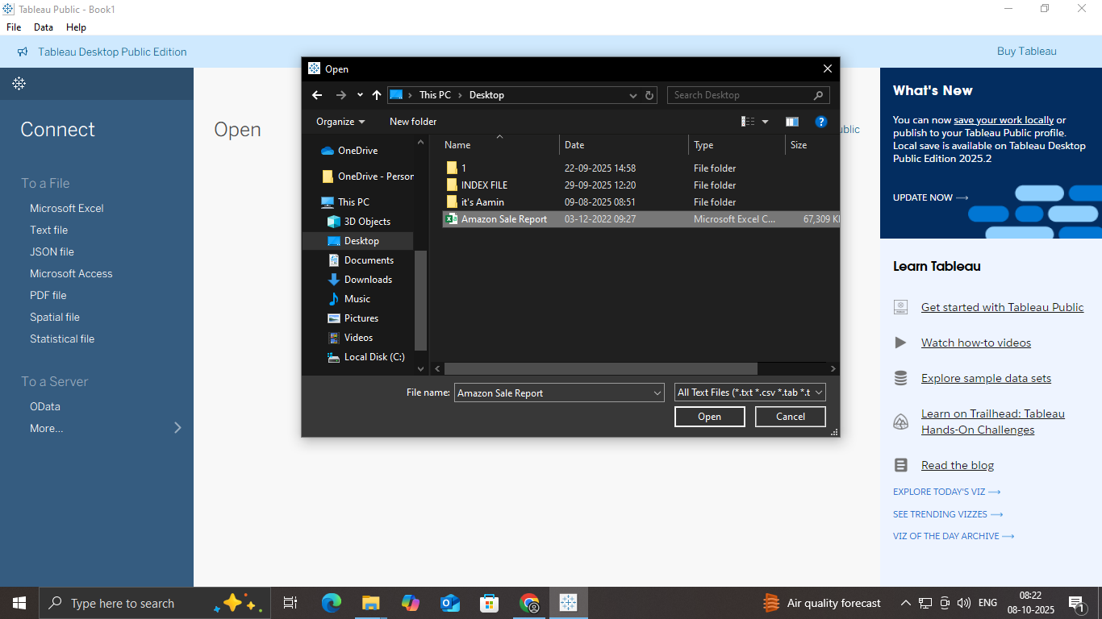

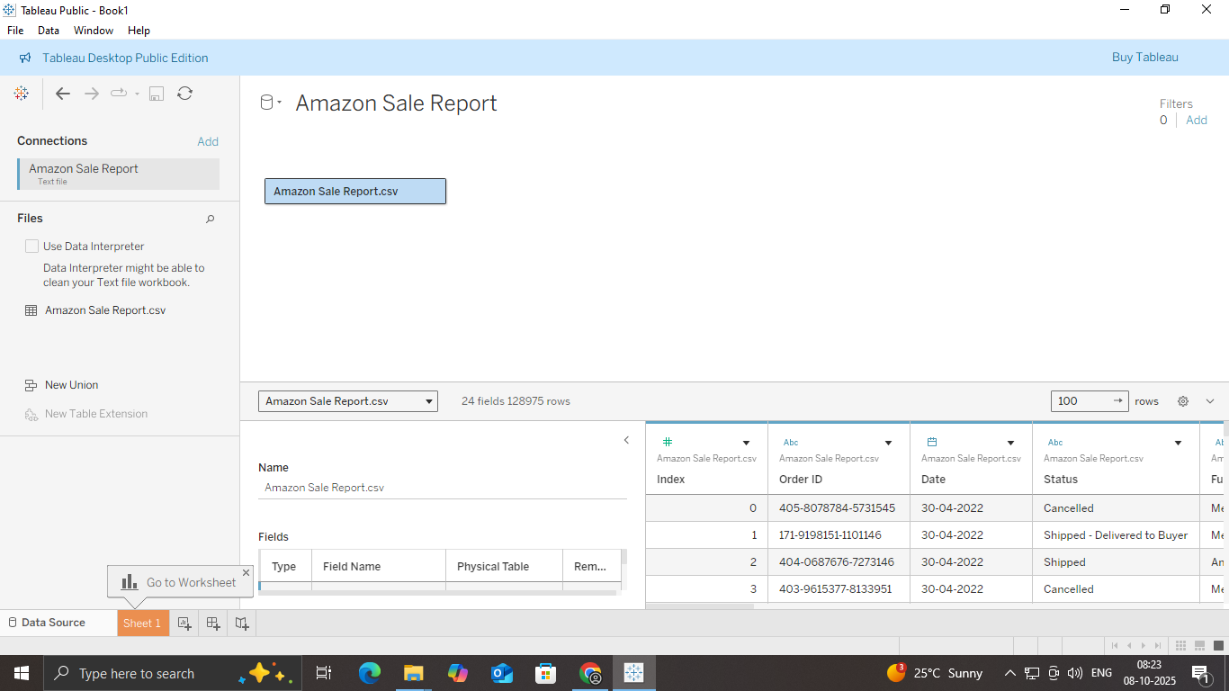

## **Step 3: Create Key Charts**

Make these basic charts for your dashboard:

### 1. Sales by Category

* Drag Category to Columns
* Drag Sales to Rows
* Choose **Bar Chart**

### 2. Profit by Region

* Drag Region to Columns
* Drag Profit to Rows
* Choose **Bar or Map**

### 3.Monthly Sales Trend

* Drag Order Date to Columns (set to Month)
* Drag Sales to Rows
* Choose **Line Chart**

## **Step 4: Build the Dashboard**

1. Click New Dashboard
2. Drag your charts into the dashboard

Customize

run display

**Q.Create different charts for Sales**

**Do data visualization and save project.**

## **Step 1: Open Tableau and Load Your Data**

1. Open Tableau
2. Click **“Connect to Data”**
3. **Click Text file**
4. Choose your file CSV
5. Load the sheet with sales data

## **Step 2: Create Different Sales Charts**

### 1. Bar Chart (Sales by Category)

* Drag Category to **Columns**
* Drag Sales to **Rows**
* Choose **Bar Chart** from “Show Me”

### 2. Line Chart (Sales Over Time)

* Drag Order Date to **Columns**
* Drag Sales to **Rows**
* Right-click Order Date → choose **Month**
* Choose **Line Chart**

### 3. Pie Chart (Sales by Region)

* Drag Region to **Color**
* Drag Sales to **Angle**
* Choose **Pie Chart** from “Show Me”

### 4. Map (Sales by State)

* Drag State to **Detail**
* Drag Sales to **Color**
* Choose **Map** from “Show Me”

## **Step 3: Create a Dashboard**

1. Click **New Dashboard**
2. Drag your charts into the dashboard

## **Save**

1. Go to **File > Save As** a **.twb** or **.twbx** file.

**Q.Download dataset from the link:**

**https://www.kaggle.com/datasets/ariyoomotade/netflix-data-cleaning-**

**analysis-and-visualization**

**Create dashboard of Sales for Netflix.**

## **Step 1: Open Tableau and Load the Data**

1. Open Tableau Desktop or Tableau Public
2. Click **“Connect to Data”**
3. Choose **Microsoft Excel** or **Text File (CSV)**
4. Select the Netflix dataset .

## **Step 2: Create Sales Charts**

### 1. Bar Chart – Sales by Genre

* Drag Genre to **Columns**
* Drag Revenue or Sales to **Rows**
* Choose **Bar Chart**

### 2. Line Chart – Sales Over Time

* **Drag Release Date or Year to Columns**
* **Drag Revenue to Rows**
* **Choose Line Chart**

### 3. Pie Chart – Sales by Country

* **Drag Country to Color**
* **Drag Revenue to Angle**
* **Choose Pie Chart from “Show Me”**

## **Step 3: Build the Dashboard**

1. **Click New Dashboard**
2. **Drag your charts into the dashboard**

**Q. Create different charts for Sales.**

**Do Data visualization and save project.**

## **Step 1: Open Tableau and Load Your Data**

1. **Open Tableau**
2. **Click “Connect to Data”**
3. **Choose your file (text File)**

## **Step 2: Create Different Sales Charts**

### 1. Bar Chart – Sales by Category

* Drag Category to **Columns**
* Drag Sales to **Rows**

### 2. Line Chart – Sales Over Time

* Drag Order Date to **Columns**
* Drag Sales to **Rows**
* Right-click Order Date → choose **Month**

### Pie Chart – Sales by Region

* Drag Region to **Color**
* Drag Sales to **Angle**

### 4. Map – Sales by State

* Drag State to **Detail**
* Drag Sales to **Color**

## **Customize Charts**

* Click **Color** to change chart colors
* Click **Label** to show values

Save

**Q.Download dataset from the link:**

**https://community.tableau.com/s/question/0D54T00000CWeX8SAL/sample-**

**superstore-sales-excelxls**

**Create a calculated field that calculates the profit margin for each product.**

## **Step 1:**

## **Step 2: Create the Calculated Field**

1. In Tableau, go to the **Data pane** (left side)
2. Click the dropdown arrow and select **Create Calculated Field**
3. Name it: Profit Margin

formula:

[Profit] / [Sales]

## **Step 3: Use the Field in Your View**

* Drag Product Name to **Rows**
* Drag Profit Margin to **Columns** or **Label**
* Format the field as **Percentage**:
  + Right-click Profit Margin in the view
  + Choose **Format**

**Q. Develop a calculated field that combines the product name and sub-**

**category.**

## **Step 2: Create the Calculated Field**

1. In the **Data pane** (left side), click the dropdown arrow
2. Select **Create Calculated Field**
3. Name it: Product and Sub-Category
4. formula:

[Product Name] + " - " + [Sub-Category]

Click **OK**

## **Use the Field in**

* **Drag Product and Sub-Category into Rows, Columns, or Tooltip**
* **It will show combined text like: Stapler - Supplies Chair - Furniture**